Kerin quintero

Ctech 450

Dr. Jackson

2/20/25

**Part1:**

### **Define the Purpose**

The chatbot is built to help customers of Quinteros' Bakery get quick answers. It can tell users the bakery’s hours, what’s on the menu, how to place an order, and where the bakery is located. This means customers don't have to search through a website or wait on hold—they get instant, friendly help.

**Flow of Conversation**

1. Greeting:  
   The chatbot starts with a welcome message that greets the user and explains how it can help.
2. User Input:  
   The user types in a question or command (for example, "What are your hours?" or "I'd like to order a cake").
3. Bot Response:  
   The chatbot looks for keywords in the user’s input (like "order," "hours," "menu," or "location") and then responds with the correct answer.
4. Error Handling:  
   If the chatbot doesn't understand what the user said, it asks them to rephrase their question.
5. Closing the Conversation:  
   If the user types "exit" or "quit," the chatbot thanks them and ends the conversation.

**Flowchart to show these steps:**

[Start]  
 |  
 [Greet User]  
 |  
 [User Input]  
 |  
 [Identify Intent]  
 / | \  
 Greeting Order Hours Menu Location  
 \ | /  
 [Generate Response]  
 |  
 [Error Handling]  
 |  
 [More Questions?]---No--> [Close Conversation]  
 |  
 Yes  
 |  
 [User Input]

### **The tone and personality**

The chatbot is friendly, casual, and helpful. It uses simple language so that anyone, including high school students, can easily understand the information about the bakery. The tone is welcoming and upbeat, making customers feel comfortable and supported.

### **Features Key**

1. **Greeting and Welcome Message:**  
   The bot starts with a friendly greeting to make users feel welcomed right away.
2. **Intent Recognition:**  
   It uses basic keyword matching to quickly figure out what the user is asking—whether it’s about ordering, the hours, the menu, or the location.
3. **Error Handling:**  
   If the bot doesn't understand a message, it politely asks the user to rephrase, ensuring the conversation stays clear and helpful.

**Create a Chatbot: Part 2**

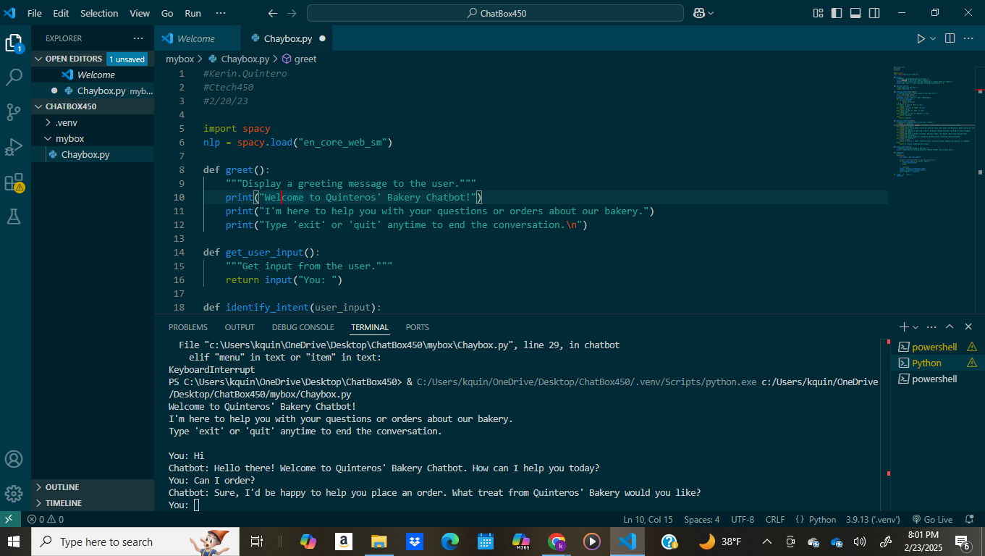

Description: This is a simple chatbot I call Quinteros' Bakery. It starts by greeting the user and then listens for questions like how to order, the bakery's hours, what's on the menu, or where the bakery is located. It uses basic keyword matching to figure out what you need and responds accordingly. If it doesn’t understand you, it will ask you to rephrase, and when you have decided you're done, you can type "exit" or "quit" to end the conversation.

Part3:

**Error 1: Slang Intent Recognition**  
Issue: When my boyfriend tested the chatbot, he used slang like “ wasgood” that the NLP module failed to interpret correctly. This led to responses that didn't quite match his intended meaning.  
Resolution: Add to the chatbot’s language understanding by updating its list of recognized keywords to include everyday slang.

**Error 2: Off-topic responses**  
Issue: My boyfriend also experimented with off-topic questions—such as asking for movie recommendations—which caused the chatbot to generate irrelevant responses or stumble on processing the unexpected input.  
Resolution: Implemented a robust error-handling mechanism that detects unrecognized inputs and returns a polite, generic response, inviting users to rephrase their query or steer back to bakery-related topics.